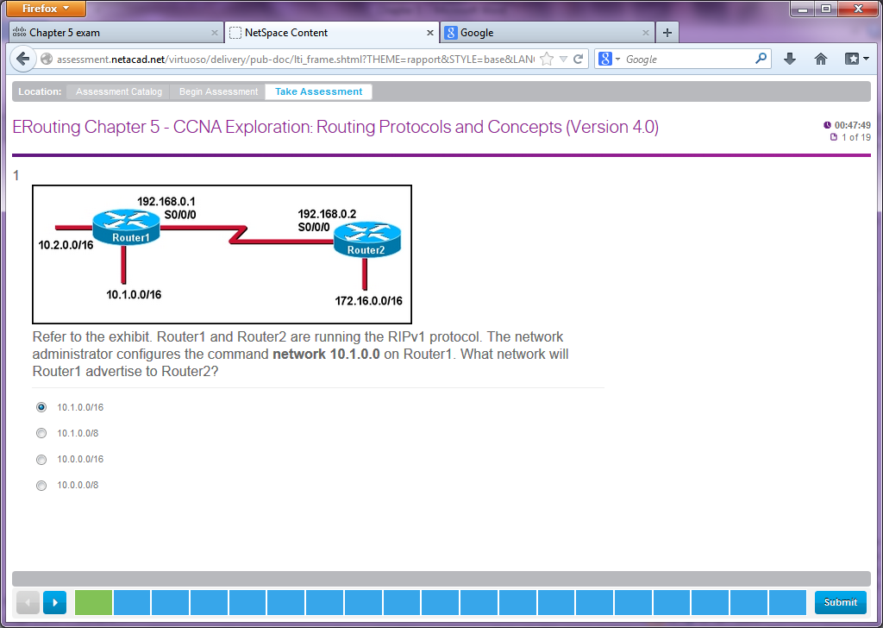

**Refer to the exhibit. Router1 and Router2 are running the RIPv1 protocol. The network administrator configures the command network 10.1.0.0 on Router1. What network will Router1 advertise to Router2?**  
10.1.0.0/16  
10.1.0.0/8  
10.0.0.0/16  
10.0.0.0/8

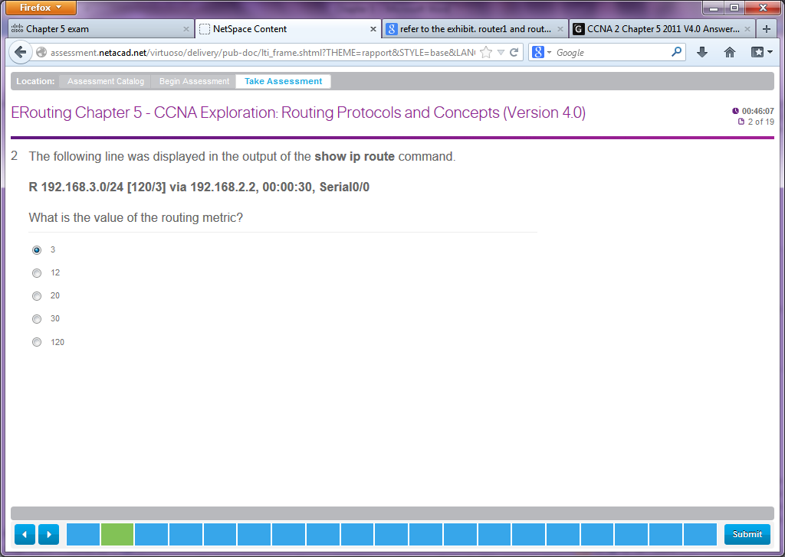

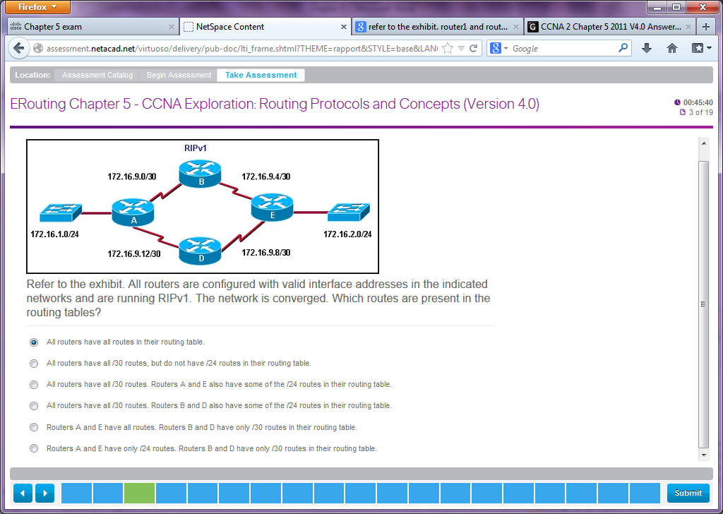

**Refer to the exhibit. All routers are configured with valid interface addresses in the indicated networks and are running RIPv1. The network is converged. Which routes are present in the routing tables?**  
All routers have all routes in their routing table.  
All routers have all /30 routes, but do not have /24 routes in their routing table.  
All routers have all /30 routes. Routers A and E also have some of the /24 routes in their routing table.  
All routers have all /30 routes. Routers B and D also have some of the /24 routes in their routing table.  
Routers A and E have all routes. Routers B and D have only /30 routes in their routing table.  
Routers A and E have only /24 routes. Routers B and D have only /30 routes in their routing table.

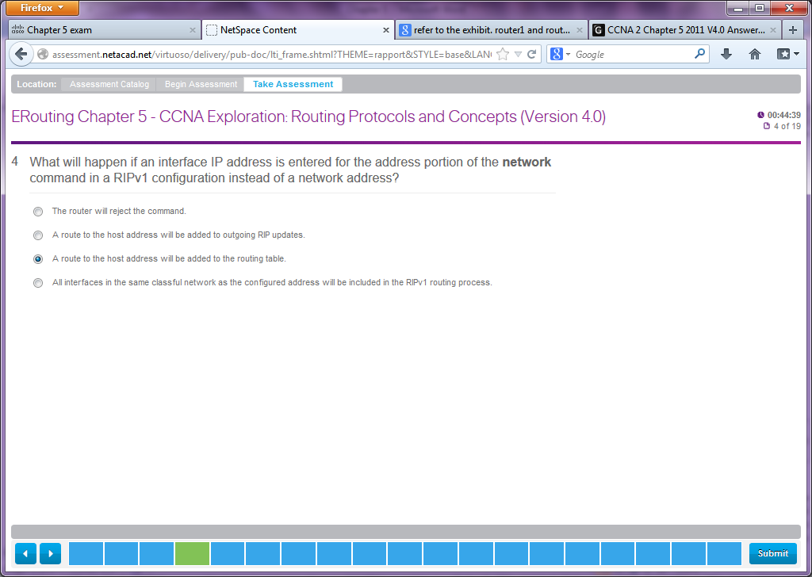

**10**. **What will happen if an interface IP address is entered for the address portion of the network command in a RIPv1 configuration instead of a network address?**  
The router will reject the command.  
A route to the host address will be added to outgoing RIP updates.  
A route to the host address will be added to the routing table.  
All interfaces in the same classful network as the configured address will be included in the RIPv1 routing process.

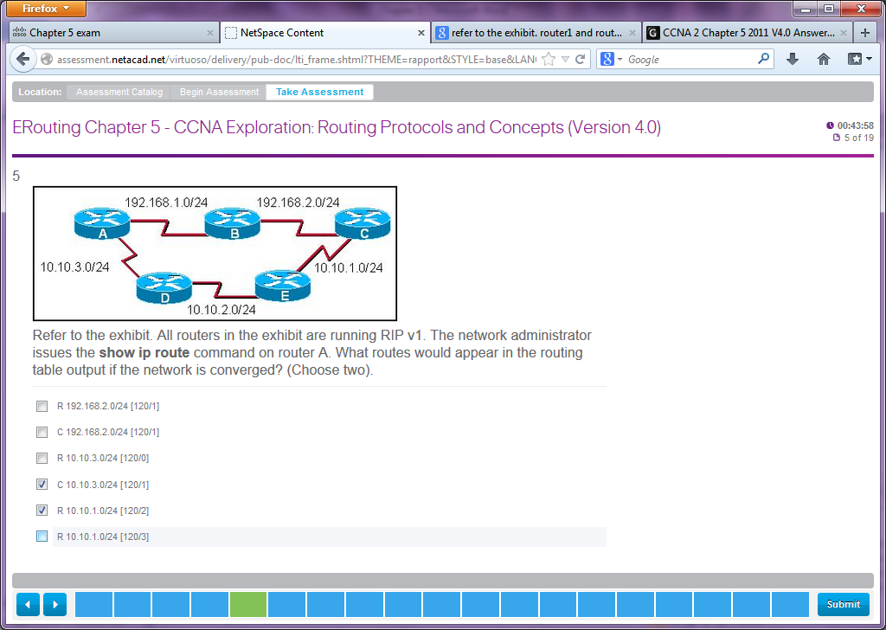

**Refer to the exhibit. All routers in the exhibit are running RIP v1. The network administrator issues the show ip route command on router A. What routes would appear in the routing table output if the network is converged? (Choose two).**  
R 192.168.2.0/24 [120/1]  
C 192.168.2.0/24 [120/1]  
R 10.10. 3.0/24 [120/0]  
C 10.10.3.0/24 [120/1]  
R 10.10.1.0/24 [120/2]  
R 10.10.1.0/24 [120/3]

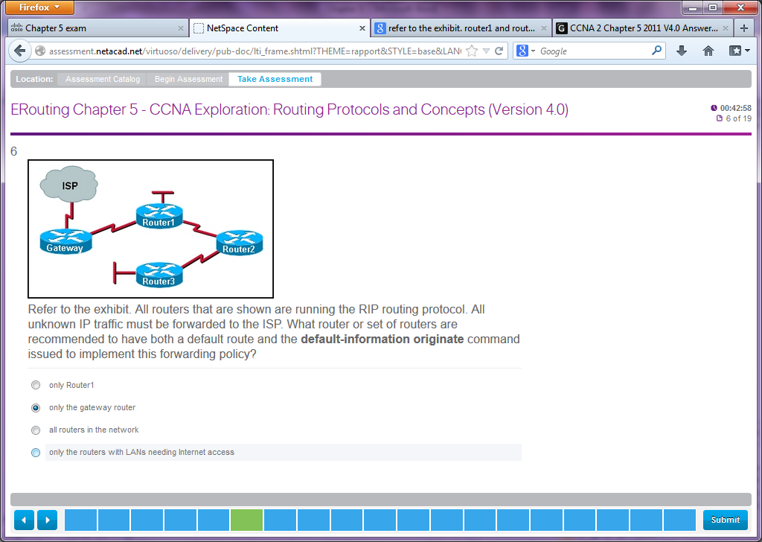

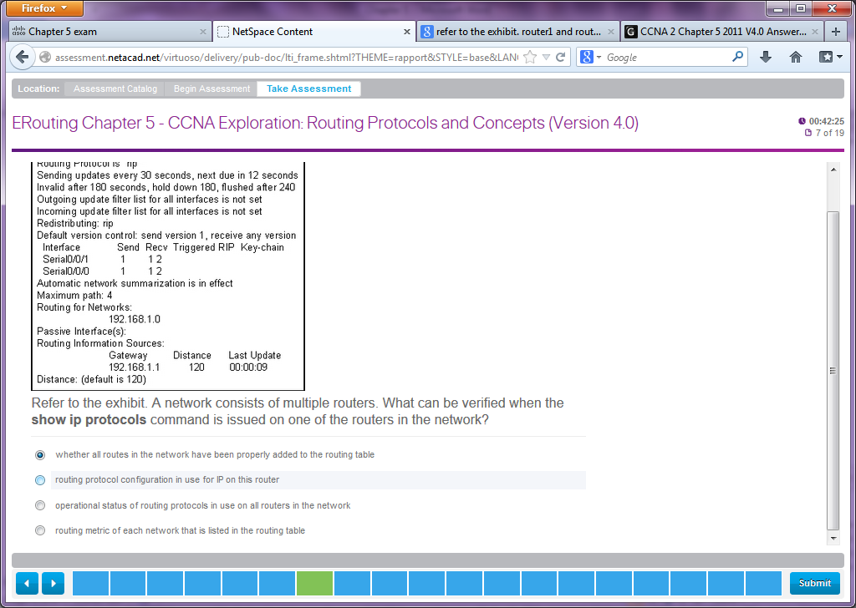

[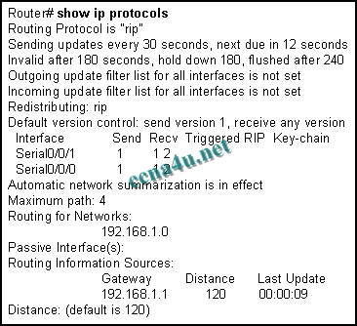](http://answers.ccna4u.net/wp-content/uploads/2011/02/145.jpg)

**Refer to the exhibit. A network consists of multiple routers. What can be verified when the show ip protocols command is issued on one of the routers in the network?**  
whether all routes in the network have been properly added to the routing table  
routing protocol configuration in use for IP on this router  
operational status of routing protocols in use on all routers in the network  
routing metric of each network that is listed in the routing table

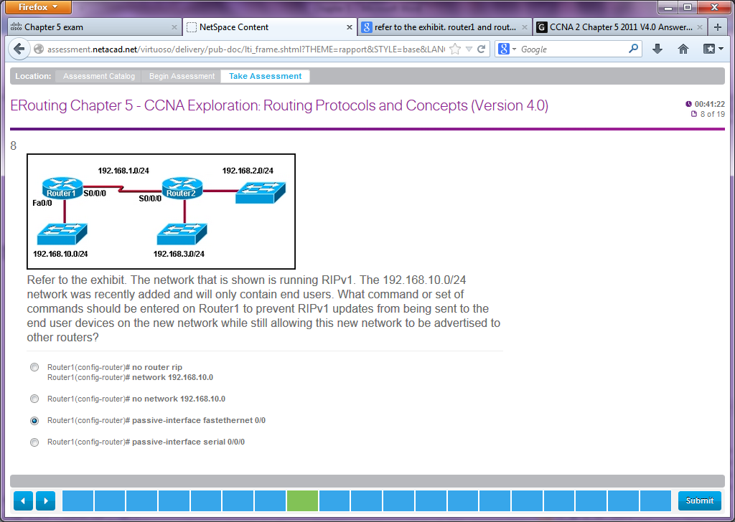

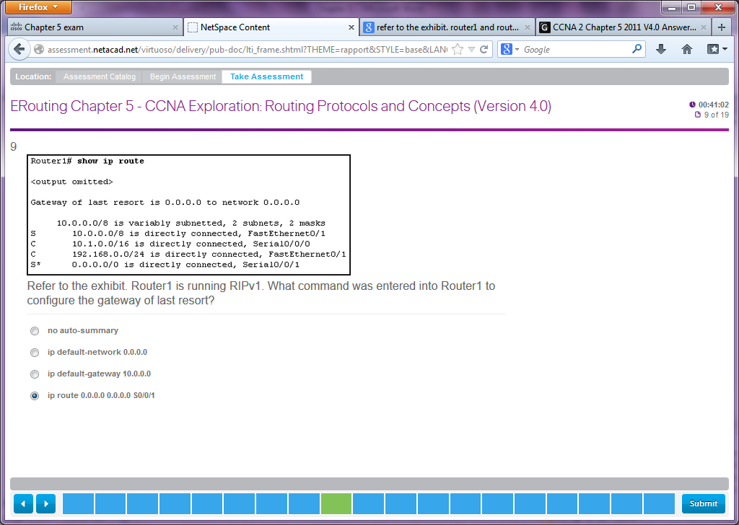

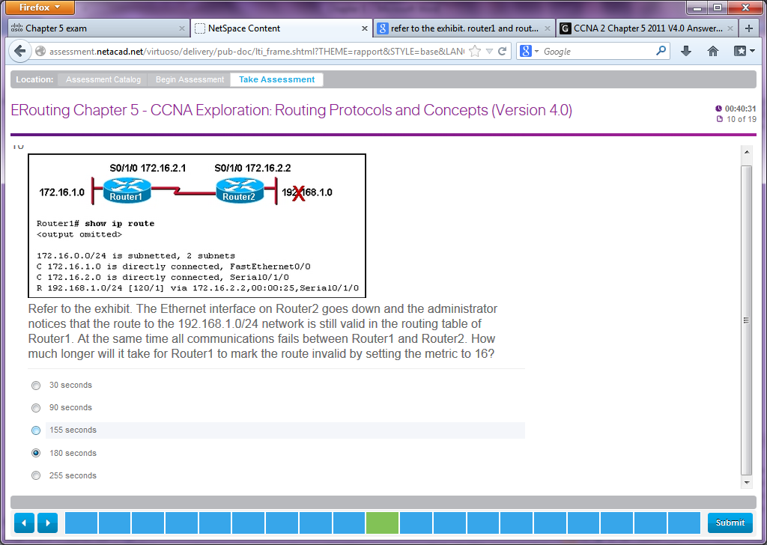

30 seconds  
90 seconds  
155 seconds  
180 seconds  
255 seconds

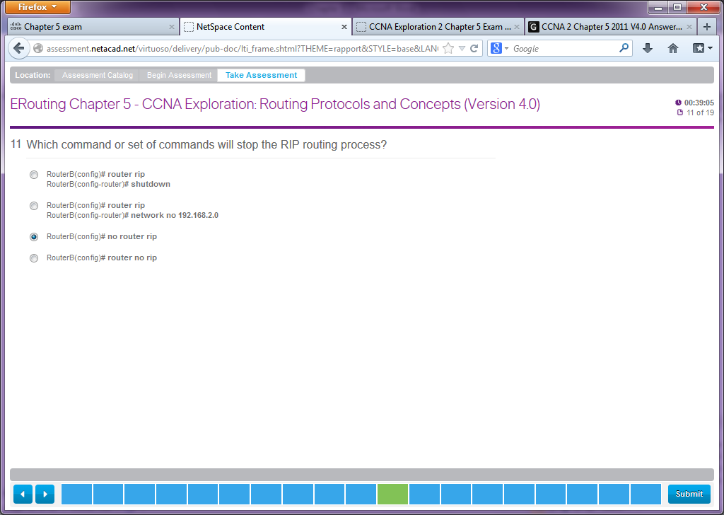

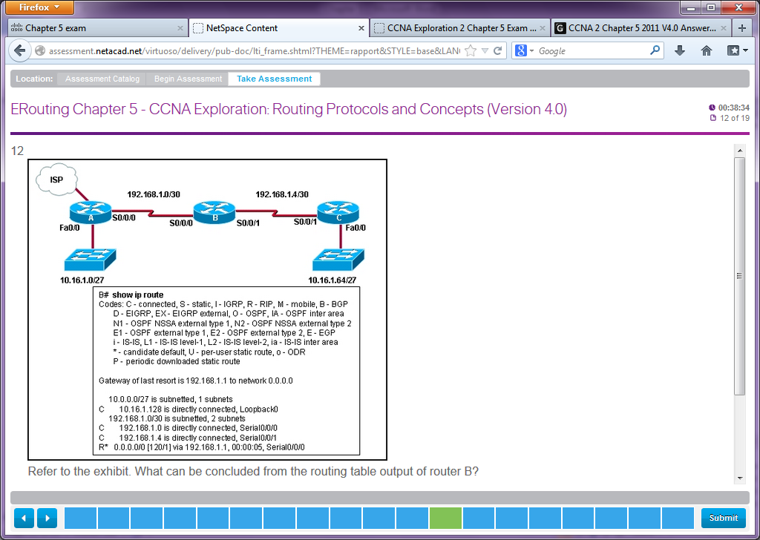

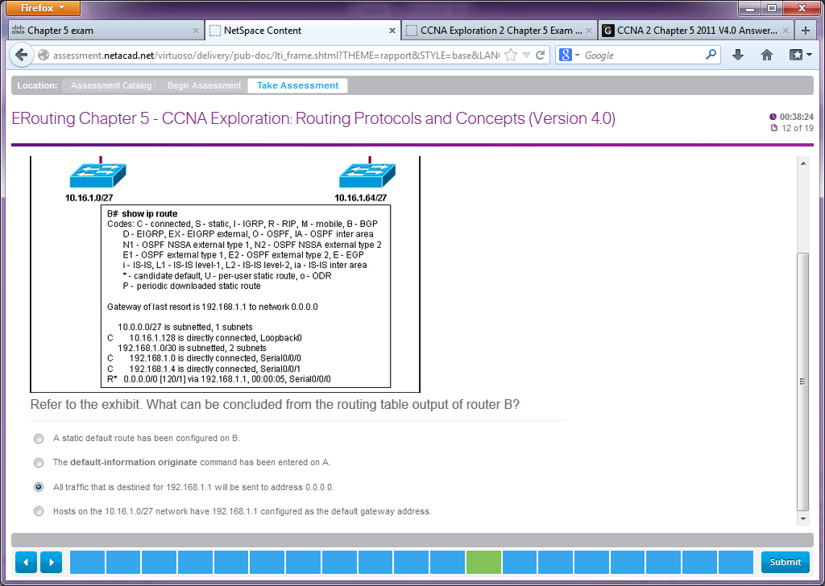

**14**.

[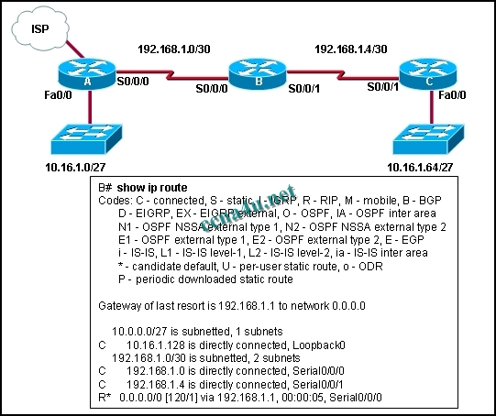](http://answers.ccna4u.net/wp-content/uploads/2011/02/176.jpg)

**Refer to the exhibit. What can be concluded from the routing table output of router B?**  
A static default route has been configured on B.  
The default-information originate command has been entered on A.  
All traffic that is destined for 192.168.1.1 will be sent to address 0.0.0.0.  
Hosts on the 10.16.1.0/27 network have 192.168.1.1 configured as the default gateway address.

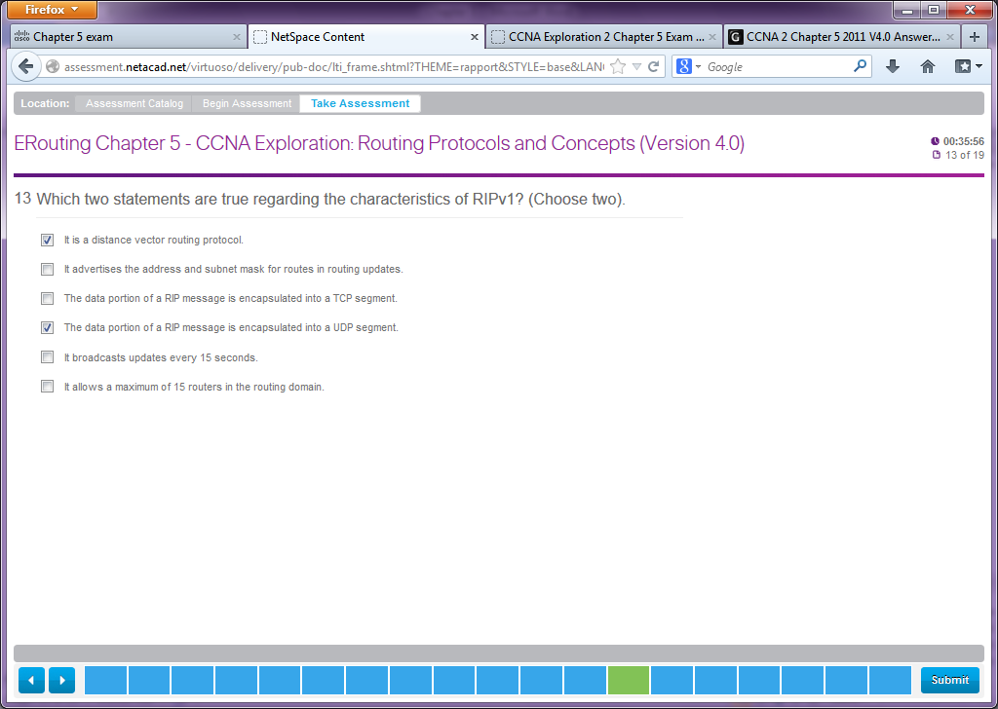

[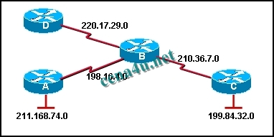](http://answers.ccna4u.net/wp-content/uploads/2011/02/042.jpg)

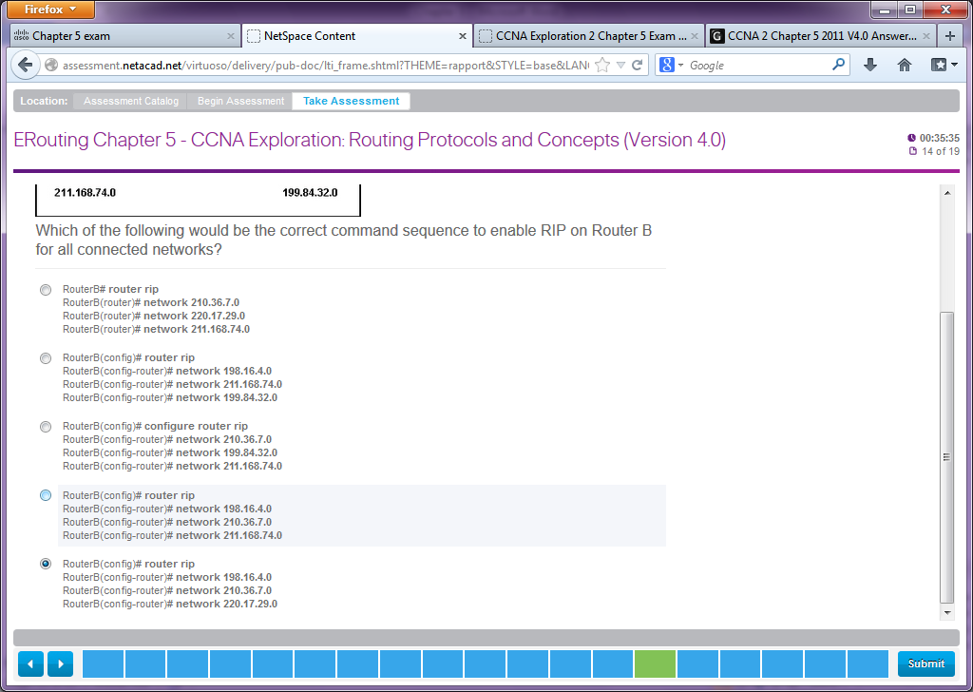

**20**.

[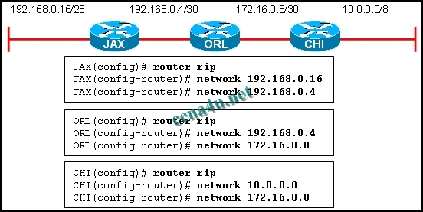](http://answers.ccna4u.net/wp-content/uploads/2011/02/074.jpg)

**Refer to the exhibit. RIPv1 is running on all three routers. All interfaces have been correctly configured with addresses in the address ranges that are shown. Which route would you see in the routing table on router CHI if the routers are configured with the commands that are displayed in the exhibit?**  
192.168.0.4/30  
192.168.0.0/24  
192.168.0.0/16  
192.168.0.32/27

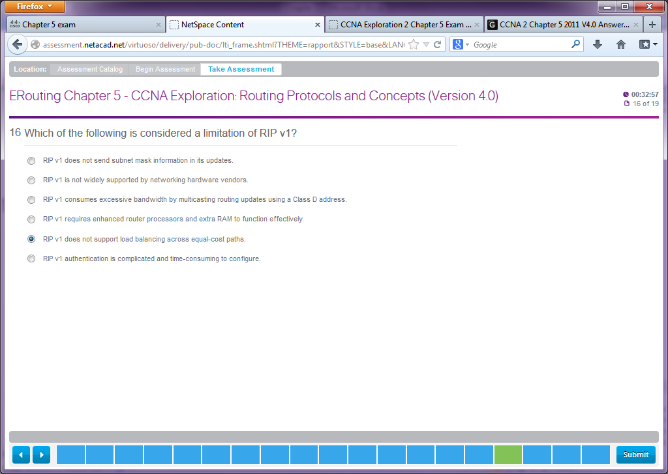

**5**. **Which of the following is considered a limitation of RIP v1?**  
RIP v1 does not send subnet mask information in its updates.  
RIP v1 is not widely supported by networking hardware vendors.  
RIP v1 consumes excessive bandwidth by multicasting routing updates using a Class D address.  
RIP v1 requires enhanced router processors and extra RAM to function effectively.  
RIP v1 does not support load balancing across equal-cost paths.  
RIP v1 authentication is complicated and time-consuming to configure.

